- Please learn the following adjectives:
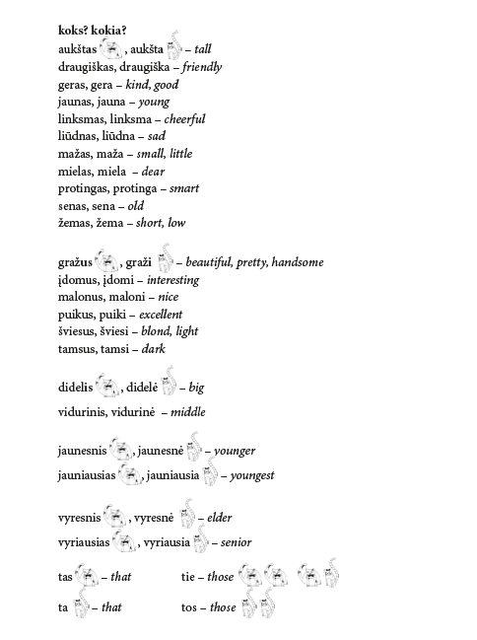
2. Find the words of opposite meaning:
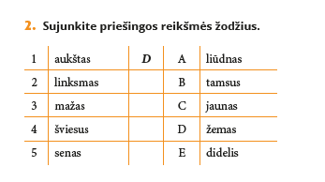
3. Find the suitable word
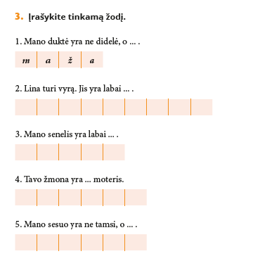
4. Group the words by following the example. 1st column – masc.; 2nd column – fem. gender

